**A**

**PROJECT REPORT ON**

**A STUDY ON CONSUMER ATTITUDE TOWARDS VIRAL MARKETING**

**Submitted in partial fulfilment for the requirement for the award of BACHELOR OF COMMERCE**

**By:**

### AYYAPPAGARI AKASH GOUD (HT. NO: 122221405032) T RAHUL (HT. NO: 122221405031)

**KALA ARNOLD JHONSAN (HT. NO: 122221405033)**

**To:**



**Osmania University, Hyderabad Under the guidance of Mrs. MEROLYAN DEPARTMENT OF COMMERCE**

### ST. MARY’S CENTENARY DEGREE COLLEGE

**ST. FRANCIS STREET, SECUNDERABAD TELANGANA STATE 2021-2024**

**DECLARATION**

**We hereby declare that the project report entitled “A STUDY ONCONSUMER ATTITUDE TOWARDS VIRAL MARKETING” , was carried out and written by us, under the guidance of MRS. Merolyan. This has not been submitted for the**

**award of any degree or diploma or certificate nor has been submitted elsewhere for the award of any degree.**

**We also declare that the dissertation is the result of our own efforts and has not been copied from any other source or submitted to any university before. We have**

**followed the guidelines provided by the university in writing the report. Whenever we have used materials (data, theoretical analysis, and text) from other sources, we have given due credit to them in the text of the report and given their details in the references.**

**AYYAPPAGARI AKASH GOUD (HT.NO 122221405032)**

**T. RAHUL**

**(HT.NO 122221405031)**

**KALA ARNOLD JOHNSAN** **(HT.NO 122221405033)**

**ACKNOWLEDGEMENT**

We gratefully acknowledge the valuable guidance and support of MRS. MEROLYAN my External Project Guide who has been to immense help in successful completion of the project.

We wish to present our sincere thanks to **Rev.Fr. Anthony Vinay – Principa**l and **Mrs. Bhagyalakshmi**

**– HOD** and **Vice principal of St. Mary’s Centenary Degree College**, For the kind encouragement and constant support extended in completion of this project work We are also thankful to all those who have incidentally

helped us, through their valued guidance, co-operation and unstinted support during the course of our project.

**AYYAPPAGARI AKASH GOUD (HT.NO 122221405032)**

**T. RAHUL**

**(HT.NO 122221405031)**

**KALA ARNOLD JOHNSAN** **(HT.NO 122221405033)**

## TABLE OF CONTENTS

|  |  |  |
| --- | --- | --- |
| **S.NO** | **TITLE** | **PAGE NO** |
| **I** | **INTRODUCTION** | **8-11** |
| **II** | **REVIEW OF LETRATURE** | **12-18** |
| **III** | **COMPANY PROFILE** | **19-34** |
| **IV** | **DATA ANALYSIS AND INTERPRETATION** | **35-55** |
| **V** | **FINDINGS, SUGGESTIONS, CONCLUSION** | **56-60** |
|  | **BIBILOGRAPHY** | **61-62** |
|  | **ANNEXURE** | **63-68** |
|  |  |  |

|  |  |  |
| --- | --- | --- |
| **Sl. N**  **o** | LIST OF TABLES | PAGE NO |
| **1** | Name | **37** |
| **2** | Gender | **38** |
| **3** | Age Group | **39** |
| **4** | Occupation | **40** |
| **5** | State | **41** |
| **6** | Are you aware of the term viral  marketing? | **42** |
| **7** | Is your purchasing decision influenced  by advice from others? | **43** |
| **8** | How often do you come across advertisements when surfing social networking sites or sending emails? | **44** |
| **9** | Do you go through the advertisements? | **45** |
| **10** | If Yes, Reason  [THE REASON WHY RESPONDENTS GO THROUGH THE ADVERTISEMENTS] | **46** |

|  |  |  |
| --- | --- | --- |
| **11** | If No, Reason  [THE REASON WHY RESPONDENTS DON’T GO THROUGH THE  ADVERTISEMENTS] | **47** |
| **12** | What you seek from advertisements? | **48** |
| **13** | Do you respond to the advertisement? | **49** |
| **14** | How often do you pass the information to  your friends? | **50** |
| **15** | What are the factors that influence you to  receive or forward messages? | **51** |
| **16** | Do you agree that viral marketing is an  effective advertising campaign? | **52** |
| **17** | Does viral marketing helps create brand awareness? | **53** |
| **18** | Do you think viral marketing is a better  technique compared to others? | **54** |
| **19** | If yes, what makes it better? | **55** |
| **20** | What according to you will be the scope  of viral marketing in near future? | **56** |

**ABSTRACT**

Internet extraordinary changed the marketing concepts. Advancements in the marketing of the products have given rise to a new form of publicity. Viral marketing is defined as the “marketing techniques that seek to exploit pre-existing social networks to increase brand Awareness among large population in short span of time”. Viral marketing is been used by Organization today through various platforms such as blogs, social networking sites to Promote their products. Viral marketing makes it easier for consumers to pass it on their peers effortlessly. It gives the most effective and fastest way of spreading products and services globally.

The focus of this paper is viral marketing-the process of creating, receiving, according to which the passing on viral marketing messages depends on consumers, category, company, Content and context. Viral marketing can be created by both the representatives of a company and consumers (like individuals or in communities), but they are being passed on by consumers. When a company creates all viral communities in a desired direction.

In digital environment, consumers can sent to each other marketing like “viruses”. Marketing messages can be forwarded quickly at low costs to a great numbers of acquaintances, friends and even to complete strangers. Simplicity, the speed of messaging, great courage, trust, especially when they receive messages from the people they know, are only a couple of the characteristics that influence the importance of viral marketing. This paper is organized as follows, first, we provide a review on the literature related to “viruses” in marketing. Then, we analyse the process of creation, receiving, sending and passing on of marketing messages.

**KEYWORDS:** Viral Marketing, consumers, brand awareness

# CHAPTER 1 INTRODUCTION

## Introduction

Marketing is the business process of creating relation with customers. With its focus on the customers, marketing is considered as one of the major components of business management.

Philip Kotler has defined marketing as

‘Marketing is the social process by which individuals and groups obtain what they need and they through creating and exchange product and value with others’

One among the strategies of companies to attract customers and to advertise their products is

##### VIRAL MARKETING.

Viral marketing, viral advertisement are buzzwords referring to a technique of marketing a product or a services where the customers help to spread the message to other websites or other users through the use of social networking sites such that it leads to multi-fold growth of the product. Viral marketing can be loosely defined as digital word-of-mouth-marketing. Viral in literal sense means anything that can spread fast (across users) and marketing refers to an action of promoting and selling products or services. Viral marketing is that which is able to generate interest and the potential sale of a brand or product through messages that spread like a virus, in other words, quickly, and from person to person. The idea is that the users must be able to choose the content to share. The main difference between viral marketing and conventional marketing is how the messages spread. Conventional marketing tries to find out where the target audience is whereas viral marketing campaigns depends on other people to distribute the advertising messages through social media network.

### REASONS WHY VIRAL MARKETING HAS BECOME POPULAR

Today viral marketing has gained popularity because of 3 reasons:

* Firstly, the entire web space has been dominated by social networks.
* Secondly, surfing the internet and especially the social networking sites has become unimaginably cheap.
* Finally, internet has become an integral part of life of individuals, especially youngsters around the world.

Emails, videos, blogs, social networking and forms are the best channels for viral marketing email marketing is the hottest and the most effective mode of marketing since it gives a forum to keep customers informed. The goal of marketers interested in creating viral marketing programs to create viral messages that appeal to individuals with high social networking potential and that have a high probability of being presented and spread by these individuals in their communication with others in a short period of time.

##### SCOPE

The study has been carried out to find the consumers perception on viral marketing.

##### OBJECTIVES

* + - To study the various social media platform in viral marketing
    - To analysis the consumer attitude towards viral marketing

##### RESEARCH METHODOLOGY

Research is defined as a careful consideration of study regarding a particular concern or a problem using scientific method. Methodology is the systematic theoretical analysis of the method applied to a field of study. Customers use viral marketing as a tool to share information with others. Customers don’t use viral marketing as a tool to share information with others. Research methodology is a process to collect information and data for the purpose of marketing decision. The data for the study is collected from both primary as well as secondary sources. The data is collected through a well developed questionnaire. The sample size is restricted to a group of 120 people among age group of 20-40. The sampling is done on the basis of random sampling. The data is collected through links and articles.

##### LIMITATIONS

The data is collected through links and articles.

1. The data is collected from a limited number of people.
2. The data has been restricted to the age group 20-40
3. The respondents who have filled the questionnaire may have been completely genuine when filing the form.
4. The data is collected from people residing on Hyderabad
5. Every individual who has filled the form may not have given a true and fair response.

### CHAPTERISATION

**CHAPTER 1:** Introduction

**CHAPTER 2:** Review if literature

**CHAPTER 3:** Company profile

**CHAPTER 4:** Data Analysis and Interpretation

**CHAPTER 5:** Findings, Suggestions and Conclusions

# CHAPTER 2

**REVIEW OF LITERATURE**

#### Danang sastri, sony heru priyant and albert k.n. anugraha (2020)

Marketing communication tools evolve and this trend enables the marketing to design and

implement powerful but still affordable marketing communication programs. Viral marketing plays an important role to communicate products offerings ranging from digital products, services and tangible products. Previous studies investigated the role of emotion in viral marketing to increasing brand awareness and intention to forward the message. In particular, the continuum of emotion (i.e., positive and negative emotion) distinguishes the effect of

viral marketing on consumer behavior through a lack of consensus on its robustness.

#### Danilo cruz and Chris Fill (2008)

The determination of the evolution of criteria of viral marketing campaigns is important because it was under taken from a practitioners ‘ perspective and is a topic not previously explored . There had little evidence of any work under taken to measure the effectiveness of viral marketing campaigns . This paper Amis to report on research undertaken to determine the key criteria that viral marketing practitioners believe should be used to measure the

success of viral marketing campaigns.

#### Eleni Rouva , Panagiota Lalou , Michalis Skordoulis and Miltiadis Chalikias (2016)

The aim of present study was to focus on the evaluation of viral marketing as a means of promoting goods and services within the Greek consumer market . The study focuses on consumer attitudes and reactions towards viral marketing practices in order to contribute to a better understanding of consumers’ behavior. The major findings indicate that viral marketing was on the rise among Greek companies due to technology development, low cost and its

immediacy in transmitting the message. All three explored media of viral marketing

i.e., email, social media and audiovisual means, are of equal importance and equal use among viral marketing and users.

#### Hongwei “ Chris “ yang, Hui Liuning Zhou (2012)

The purpose of this paper is to integrate the Theory of planned Behavior (TPB) , technology

Acceptance Model ( TAM ) and palka *et al .’s* model to predict young Chinese consumer’s mobile viral attitudes , intents and behavior . It pays to foster Chinese consumers ‘favorable attitudes toward mobile marketing. it is advisable to know both target consumers and their associates very well. it is recommended to convince Chinese consumers that their friends and relatives can benefit greatly from viral content forwarding. Mobile messages with

entertaining, useful, relevant and self-involved values can go viral more easily.

#### Kalpak K. Kulkarni, Arti D. Kalro and Dinesh Sharma (2019)

This study aims to investigate the influence of Big Five Personality ( i.e. openness to experience conscientiousness, extraversion, agreeableness and neuroticism) on young

consumers intentions to share branded viral video advertisements. Further, this study also demonstrates that the advertising appeal (informational versus emotional) used in the viral advertisement moderates the effects of specific personality traits on the sharing of viral ads.

#### Lina Xiong and Clark Hu(2010)

The purpose of the paper was to focus on the pricing strategy for viral marketing in the context of the hotel industry and purpose three typical price-network size schedules to be tested. The paper further proposes controlled experiments in hotel industry context to examine the performance of those schedules.

#### Maria-Jose Miquel-Romero,Consolacion Adame-Sanchez(2013)

Most of the studies focused on viral marketing consider the reception of a message only from another person, not from a company. This study focuses on the opening of a message from a company a its forwarding to a colleague. The purpose of this paper is to identify the antecedents that may determine the opening of e-mails from companies that endeavour to promote their products, and what may motivate individuals to forwards such message to others.

#### Muzaffar and Kamran(2011)

Information is considered as a valuable incentive in mobile advertising and recipients reacts positively to the advertisements that transfer quality information to them. Information provided to the consumers by means of mobile phones should consists of the features like accuracy, timeliness and usefulness for generating positive consumer’s attitude. Consumers are interested in receiving messages that are relevant for them ( Haghirian et al. 2005) a study of Muzaffar and Kamran (2011), revealed a positive association between perceived

informativeness and consumers attitude towards SMS advertisements. Therefore, more importance should be given to the quality of information delivered through the SMS advertising messages.

#### Morteza Hendijani Fard and Reza Marvi (2019)

In the preceding decades, due to the advancement of social media, traditional marketing has become less significant. Managers and entrepreneurs are seeking novel, effective and

efficient ways both for new and technological products/services. Drawings on the theory of reasoned action, information adoption model and technology acceptance model, the purpose of this paper is to examine the effect of viral marketing on purchase intention of mobile application users in Iran.

#### Michael Beverland, Angela Doubele and Francis Farrelly (2015)

This study is unique because it proposes an alternative focus to a fundamental metaphor and has both conceptual and practical value. Viral marketing draws heavily on the success of a few mythic campaigns. However, the viral metaphor limits previous limits previous

perspective as to why consumers engage with content and importantly, why they pass it on. The paper aims to discuss this issue.

#### Nuzulul Kusuma_Putri_Ernawaty (2020)

Today, viral marketing is popular as a highly effective marketing strategy with a low cost for mass targeting. This is suitable for the Universal Health Coverage campaign which seeks to attract the whole nation’s population to voluntarily register with social health insurance. It uses the target market itself as a weapon and the marketing content as a bullet. This study aims to determine the exact viral marketing content for the Universal Health Coverage campaign in Indonesia.

#### Patrizia Battilani and Giuliana Bertagnoni (2015)

The main aim of our study is to demonstrate that the Italian way to marketing include not only the “advertising artists” but also what can be labelled as the social network approach, which was mainly used by cooperative enterprises. Focusing on the study of the Granarolo

co-operative, the paper discusses the social network method of marketing as it emerged during the 1950s and 1960s in Italy.

#### Reyek and Degraeve (2003)

However, people usually perceive low level of informativeness in mobile advertisements that they find boring. Consequently, they develop a negative attitude towards them (Blanco et

al., 2010). Reyck and degraeve (2003) maintain that advertisements containing interesting and customized information that matches customer preference will results into their positive attitude towards mobile advertisements. Furthermore, message delivery timings with a right messages frequency could also results into a positive customers “attitude towards mobile

marketing.

#### Rishi Raj Sharma and Balpreet Kaur (2019)

This study explains factors behind the creation of “viral infection” specifically with regards to commercial e-mails targets to individual with high networking potential. The purpose of this paper is to identify factors influencing the opening and forwarding of commercial emails

received directly from companies to further promote products via sharing by consumers to create viral infection.

#### SL Wang, NTN Lan, (2018)

In general, it has been believed that perceived informativeness of consumers is an

imperative aspect which may influence consumers attitude towards viral marketing (SW Ler, 2014). Informativeness is able to change recognition, attitude, satisfaction, and effect of providing resources. In short, informativeness perception is considered as the evaluation of people whether all of the information that they receive is useful or useless.

#### Sahar Hosseinikhah Choshaly and Marva Mirabolghasemi (2020)

Viral marketing through the internet is an important and cost-effective way to promote products. This study aims to examine the impact of viral marketing strategies (level of

information, level of entertainment, irritation level and source credibility) on the purchasing intention of eco-labelled products.

#### Tarisai Fritz Rukuni (2017)

The advent of viral marketing in south Africa has been supply focused and retail operators did not realise the importance of including customers views during the creation of viral marketing strategies. Failure of these stores to incorporate customers’ views during the

crafting of viral marketing strategies. Failure of these stores to incorporate customers views during the crafting of viral marketing strategies, leads to ineffective viral advertising

campaigns, product boycott and decrease in sales. Given the constant change in consumer needs and expectations, an understanding of customers opinions towards viral marketing strategies adopted by a retail store in Johannesburg. For that reason, it is important for retail stores to understand their customers perceptions of viral marketing strategies.

#### Zernigah, Kiani Irshad; Sohail, Kamran. (2012)

Viral marketing has become an increasingly popular promotional tool for many brands [Eckler and Bolls,2011]. Its advantages over the conventional media include its ability to

deliver more targeted and personalized messages; high speed of message transmission and behavioral responses are potential more quantifiable [Bampo et al., 2008]. Viral marketing is less costly [Woerndl et ai., 2008], can reach to a large number of audience relatively quickly [Cruz and Fill, 2008; Woerndl et al., 2008] through the use of social contacts [Woerndl et al. 2008] and its trustworthiness, specifically when the message is delivered by people to their social networks [Porter and Golan, 2006;Evans and McKee,2010]. Moreover, viral marketing messages are free from geographic boundaries and time constraints that make it global as compared to the conventional communications [Goldsmith and Horowitz, 2006].

Based on the above studies we can conclude that the viral marketing was increasing rapidly in recent times. It is the easy way to promote the product [or] brand. Most of the researches are

also said that in coming time the huge growth in the viral marketing. In the above researches we

can come to know the social medias and different platforms were playing a vital role in vial

marketing like face book, Instagram and whatsapp etc. more marketing is done by the consumer mouth-to-mouth. So the marketing of product done easily with low cost.

# CHAPTER 3

**COMPANY PROFILE**

## Company Profile

Viral marketing is a marketing strategy that involves producing captivating content that raises awareness of a product or brand by creating a word-of-mouth

Viral Marketing is a business strategy that uses social media platform to promote a product or a service. In other words, it is a digital marketing strategy that tries to convince the customer to become a brand advocate of the existing products or services.

Viral marketing is other forms of marketing is its consumer-to-consumer nature and rather than companies communicating information about a product or a brand it is consumers who are spreading information to one another.

The growth of social networks significantly contributed to the effectiveness of viral marketing. As of 2009, two thirds of the world's Internet population visits a social networking service or blog site at least every week. Facebook alone has over 1 billion active users.In 2009, time spent visiting social media sites began to exceed time spent emailing. A 2010 study found that 52% of people who view news online forward it on through social networks, email, or posts.

Some of the major examples of top viral marketing campaigns are:

* 1. **Apple: Shot on iPhone**

Being an iconic brand in the market, even Apple requires a marketing strategy that would help the to retain their customers. And with the launch of the iPhone X, Apple put out its 'Shot on iPhone' campaign to promote how amazing their cameras were.

The company focused on the selfie aspect that people can share on social media which create a buzz among people. They find it a great product. The camera quality made people start filming and creating content. These beautiful pictures do not have any direct link to the brand except for the tag- Shot on iPhone.

People have started sharing the Shot on iPhone images and videos. The campaign became a great hit because of the memes. Apple had successfully portrayed itself as the best camera phone for all camera lovers or content creators out there.

* + 1. **Apple's new type of viral advertising.**

Apple has been granted a patent for a new viral advertising management system that can track ads or media content as it is shared via different methods, such as email, texts and social networks

like Facebook and Twitter. The patent also says that it can store users' names, addresses, and age in a database.

This does not mean that Apple is going to launch a viral advertising product - the company has a long history of focusing on devices and apps, not advertising. Nor does it mean that Apple is going to start tracking your consumption of social media But it is interesting that Apple is even thinking about the topic, given the company's recent renewed interest in increasing its advertising business.



**Figure 3.1**

* + 1. **Focusing on attractive value proposition**.

Apple's value proposition is "beautiful design that works right out of the box with ever- smaller packaging". The world's largest IT company by revenue has been able to avoid price wars with competitors by emphasizing its unique value proposition in its marketing communication messages. Apple is a unique company in a way that it is a design firm, s media platform, a publishing company, a software powerhouse and a computer manufacturer -all at the same time. Such a position allows the company to communicate its value proposition to target customer segment in a cost-effective manner.

* + 1. **Effective use of product placement:**

An important feature of Apple marketing strategy is that the world's largest IT company by revenue does not use Pay-Per-Click (PPC) online ads on with Google or Facebook. Instead,

marketing strategy of Apple relies mainly on two pillars-product placement (especially with celebrities and in popular shows) and the buzz created by positive reviews in the media.

* 1. **iHeartDogs: 0% off**

iHeartDogs is a company that was established for a social welfare purpose. Every time people but their products, they donate meals to dog shelters. Keeping to their core, the company started running ads on Facebook to attract more people to donate. The campaign said that they will provide nothing for buying their products. Instead of discounts, they promised to double donations from purchases made over the weekend. They launched a 0% off campaign from Black Friday to giving Tuesday. The ad on Facebook read 0% off but the company ende with quadrupling

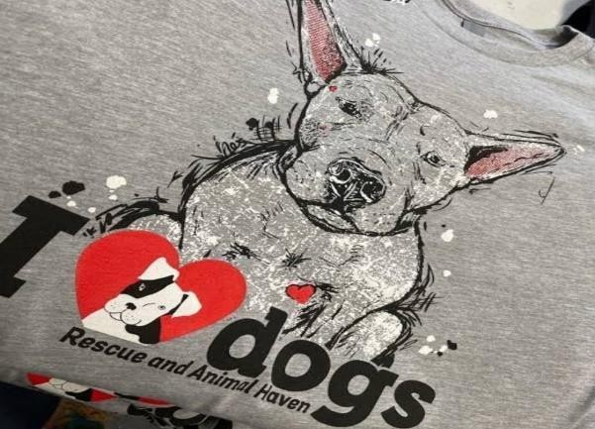sales.

**Figure 3.2**

In 2014, Justin Palmer started a Facebook Page called I Love Dogs, which quickly grew to attract over a million fans. In 2015 Justin co-founded iHeartDogs.com with Marshall Morris, a US army veteran. Inspired to help shelter dogs and offer support to veterans, the duo now offers a diverse product line of toys, gifts, blankets and more for pups and people. With each purchase, they make a donation towards one of their charitable give-back programmes. GivingTuesday was created in 2012 as a day that encourages people to do good. It has since grown into a global movement that inspires hundreds of millions of people to give and celebrate generosity. As the festive season and #GivingTuesday approached, iHeartDogs wanted to encourage the spirit of giving by running a variety of Facebook video. and photo ads that emphasized the direct impact of a customer's purchase in helping shelter dogs and veterans.

One video ad showed a variety of cute, dog-themed Christmas tree ornaments, with the messaging: "Help shelter dogs this festive season-every purchase you make donates meals to keep their bellies full." A "Shop Now" button linked to the Christmas Miracle Rescue Ornament Collection product page on the company's website.

* 1. **Twitter's Launch Campaign**

Twitter, a microblogging platform, has set a great example of viral marketing Conference brings together thousands of millennials interested in music, interactive media, and film every year. The SXSW is held in Austin, Texas. Twitter as a startup negotiated with the organizers to place huge screens around the venue. These were updated with real-time messaging and attendees with Twitter accounts participated in the campaign and promoted the brand.

This created a massive impact, demonstrating the arrival of the new social media age Twitter gained a new reputation and many more subscribers who wanted to become part of something new. Thus, overall a very successful viral marketing campaign



**Figure 3.3**

Viral marketing uses social media to help spread a message far and wide to as many people as possible. Of course, because of this immense reach, going viral is a key goal for a any social media manager. Oftentimes, an ad goes viral organically. Something triggers a response in the audience, whether that be clever writing, humor, or a heartfelt message, and they share with their friends

and followers who share with their friends and followers and before you know, the piece is viral.

When aiming for creating a viral Twitter campaign, your goal is to

have your audience spreading the message. Twitter, of course, makes it easy for you because it's a platform made for precisely that: sharing interesting content.

Reaching millions of people all around the globe might have seemed impossible 50 years ago (like Bitcoin seemed unreal). But many things seemed impossible before a revolutionary idea came around. Now, with the rise of social media in our lives, especially Twitter, it's easy for a marketer in the Czech Republic to reach an audience in Alaska-within moments even,

One way to get your word out is to, of course, promote your hashtag. However, that can take time and resources away from you. It's not ideal and it's certainly not organic. The key to a great viral Twitter campaign (just as it was for legendary ads of the magazine years) is content, content, content. You need to be clever, funny, thoughtful, memorable, and, most importantly, relevant! Your followers are much more likely to share what you've taken so much time to put together if something within that piece resonates with them, taps into an emotion.

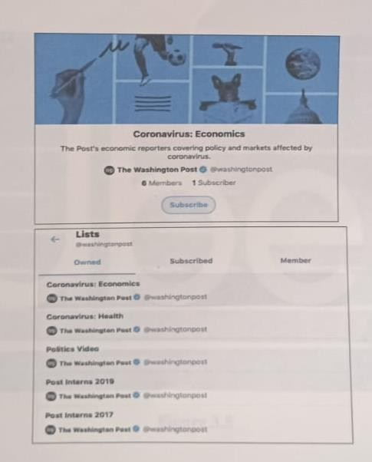

Figure 3.4

* 1. **Uber's Launch Campaign.**

Another great example of viral marketing that incidentally took ree in Austin, Texas.

Uber became a social sensation at the south by south west festival. They offered free rides to attendees during the conference and festival. This created a sensation during the event and people started discussing it on social media. Wouldn't you? Everyone wants to experience free service and that too in such style! The deluge of information back and forth was to much that a social media platform collapsed.

Targeting the right people at the right time is very important. Young participants of SXSW no doubt took to social media and in no time it became viral on social media.



Figure 3.5

Uber is one of the great innovations of the 21st century, a pioneer of both rideshare platforms and the concept of on-demand marketplaces. In addition to its technical achievements, Uber's multifaceted marketing strategy was a crucial contributor to its immense success. Any app

marketer-rideshare or otherwise-is well-advised to study Uber's marketing strategy to see how the company drove growth from the very start.

The launch period for apps is always a crucial window for marketers, but rideshare platforms face a few additional challenges their two-sided marketplace means that they need to attract drivers and riders at the same time. The ideal solution is to promote early adopters initiatives, helping both groups feel like insiders. Uber handled this masterfully by leveraging early adopter advocacy and offering rewards for loyal customers.



Figure 3.6

#### Spotify Co-marketing with Facebook

Ever wonder how did Spotify achieve such fame in a short time?



**Figure 3.7**

Spotify, a startup founded in2008 in Sweden and provides audio streaming and media. services. It had started with free service for UK customers in February 2009 and by September it had to halt free service and rely on invite- only. Then in 2011. it initiate co- marketing with Facebook to solidify its position playlist can be published on a user's Facebook page and at the same time, another user can listen to it with a single click.

As of the second quarter of 2021, Spotify has 165 million premium subscribers worldwide and is available in more than 15 countries including the UK, the US, and the MENA region. This is another great example where a simple collaboration with social media has made the Startup go viral and increased users, especially where services are based on a Freemium model.

All around the world Spotify has made a place in the hearts of audiophiles. The reason is the fact that they are a music streaming platform and everyone is a music lover. Also, they are famous for their wacky advertising marketing faces, and exact usage of consumer psychology for that matter.

Once you sign up for this audio streaming service and begin using it, they will notice your listening habits. As you go about interacting more and more with Spotify, listening to music and podcasts and all, Spotify will get to know you more.

Spotify is high on artificial intelligence and machine learning. They know patterns that you listen to music too, they know every input needed to suggest the next song. These inputs allow quite everything at the Spotify headquarters. Listening is everything' is the motto of this audio streamer. While you listen to songs that they provide, they listen to your listening patterns. They thus create a pattern that can eventually predict your mood and the genre of music you may want to listen to in the future.



**Figure 3.8**

#### Dropbox Referral Offer

Another great example of viral marketing was set by Dropbox. Dropbox, the go-to cloud storage service to save your files and data. And the best part is once stored in virtual space, you can share and sync your files without the hassle of sending attachments individually.

They set a great example of affiliate marketing that went viral, Dropbox offered 500 MB of free storage for every referral and signup by an existing customer. What happened? Well, Dropbox saw registration shoot up by 60%. Even now, a major part of new customers is deriving from word of mouth.

By offering a reward to an existing customer, they achieved effective marketing by customers and a great loyal customer base. And when most of your customers are businesses, their reach is huge. Dropbox has over 500 million users as of 2016 and is poised to cross over a billion users soon.

It is not always necessary to come up with funny content to become viral. The company can reach a larger audience even by offering that customers are ready to accept.



**Figure 3.9**

Every business wants free positive publicity, but getting people to talk about your company and product for free isn't easy. Dropbox, a cloud storage company, has been able to grow from a software startup with fewer than 100,000 users to more than 4 million users in fewer than two years.

When Dropbox launched, its market was already highly competitive with dozens of cloud storage companies battling for users. The company realized, however, through looking at comments in forums and reading blogs, that users weren't really satisfied with competitor products. These other products didn't work all of the time and would create file errors. In others words, users couldn't rely on these solutions. Dropbox decided to make a simple file storage application that worked. Customers talk about great products, so the first step in word-of-mouth marketing success is to have a product worth talking about..

Dropbox tested landing pages and a private beta program as an effort to generate interest in the product and begin to build a community while the product was still in the development process. Letting users into the process early helped to provide a sense of ownership while it gave the company valuable feedback needed to make the product better.

Dropbox's public launch plan looked like other product launch plans. They had planned to use some pay-per-click advertising, launch at an industry conference and hire a public relations firm. That all sounds pretty smart right? It didn't work for them. The cost of customer acquisition was too high because the keywords they were bidding on were too expensive. Basically, the traditional ways to launch and market a company weren't allowing Dropbox to scale its growth. Still, they realized they were still growing despite the fact that these efforts weren't working. This growth was due to word-of-mouth buzz about their product.



Figure 3.10

#### "I Want Mint" Badge



Figure 3.11

Having people post "I Want Mint" badge to their blogs, Mint propelled to attract more cusmers.

If you talk about the start up that received so-called overnight success, then Mint is one of them. Mint proved that with its unique marketing strategy and great product for content creators. Mint used its blogs to create awareness and gave special benefits to users who put "I Want Mint" badges on their blogs or social media pages. That was great free advertising!

They were able to make customers feel special without spending money. And from this badge, Mint got free advertising on 600 different blogs from both normal people and influencers. Further, achieved recognition as providing useful information and being concerned about users. This way it ended up attracting more users and bloggers to write blogs on Mint for free.

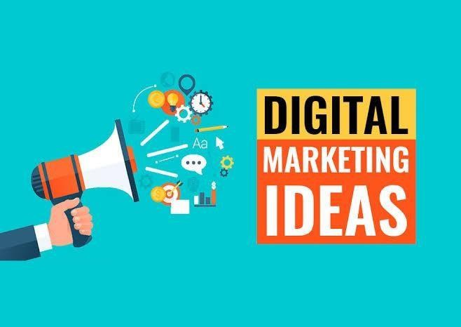

**Figure 3.12**

**Mint** proved that with its unique marketing strategy and great product for content creators. Mint used its blogs to create awareness and gave special benefits to users who put "I Want Mint" badges on their blogs or social media pages. That was great free advertising!

They were able to make customers feel special without spending money. And from this badge. Mint got free advertising on 600 different blogs from both normal people and influencers.

Mint officially launched in September 2007. In November 2009, Intuit bought Mint for $170 million. At the time, Mint had over 1 million users and was adding a few thousand new users every day. Four years later, Mint has over 10 million users.

Growing to millions of users in two years would be a success story for any consumer web company. When you add in the fact that this is a finance product with no real viral component (Mint is personal, not social), it makes it even more impressive. People had to hand over their financial data to a young company, so Mint had an uphill climb in gaining trust with users. As we'll see, being a consumer financial startup was a big turn off for investors, too.

Mint was not the first web-based money manager software (another strike to the first-mover advantage theory). There were a few heavyweights already occupying the market - Quicken Online, Microsoft Money Online, Wesabe, Geezeo, and others.

#### ALS Ice Bucket Challenge

This Ice Bucket Challenge is also known as ALS Ice Bucket Challenge. The campaign was started with the purpose to promote awareness of the disease Amyotrophic Lateral Sclerosis and encourage donations to research. Many big personalities like Bill Gates, Oprah Winfrey and Justin Bieber took part in the campaign to raise awareness.

Famous CEO taking part in Ice Bucket Challenge

They have been seen pouring a bucket of ice water on their heads either by themselves or someone else which attracted people around the world to take part in the campaign. The campaign went viral on social media and helped the organization to raise over $220 million and became the fifth most popular Google search in the year 2014. Even after the campaign, the donations to ALS remained 25% higher than a year before the campaign. ALS was able to raise awareness by breaking the mould and doing something out of the box.

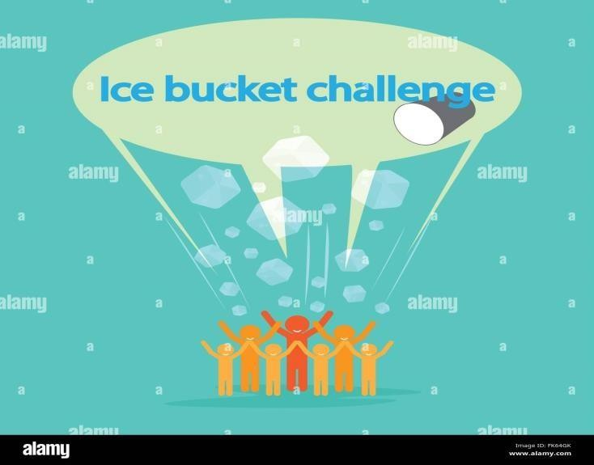

**Figure 3.13**

The viral challenge actually kicked off a few months ago, when Pete Frates, a 29-year-old Massachusetts resident diagnosed with ALS, started posting about it on social media with his father's help. It really gained traction, however, 10 days ago when friends and family of the former Boston College baseball player used it to raise awareness about his plight.

Frates was diagnosed with the neurodegenerative disease, which has no cure, in 2012. He is now paralyzed, cats through a feeding tube and cannot talk

He concept behind the ALS ice bucket challenge is simple: you film yourself being doused

with a freezing cold bucket of ice cube-filled water and then post the video and publicly nominate three friends via social media to raise money for ALS The 'challenge and nominate strategy that formed the foundations of this explosive viral marketing campaign is one the biggest drivers of its overall success.

Speaking of the ice bucket challenge, Max Lenderman, CEO of the advertising agency School explained: "It's totally own-able, unique, iconic and simple. It's highly broadcastable, but it's so personal because of the calling-out aspect."

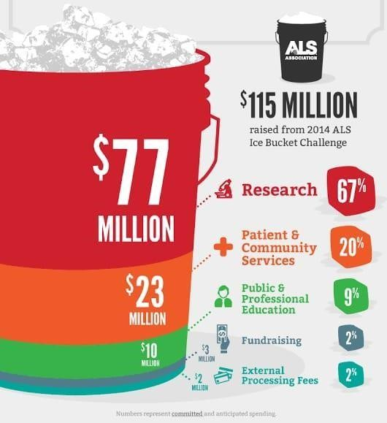

Figure 3.14

# CHAPTER 4

**DATA ANALYSIS AND INTERPRETATION**

Data analysis is the process of examining and interpreting data to extract meaningful insights and draw conclusions. It involves using various analytical and statistical techniques to organize, clean, and transform data into a format that is suitable for analysis. The goal of data analysis is to discover useful information that can help businesses make better decisions and improve their operations. This can involve identifying patterns, trends, and correlations in the data, as well as performing predictive modeling to forecast future outcomes. Data analysis is used in a wide range of industries, including finance, marketing, healthcare, and more.

Data interpretation is the process of analyzing and making sense of data to derive useful insights and draw conclusions. It involves examining data sets to identify patterns, trends, and

relationships that can provide valuable information for decision-making. The interpretation of data can involve using statistical methods, visualizing techniques, and other analytical tools to understand the significance of the data. Data interpretation is important because it helps organizations to better understand their operations, customers, and market trends. With

accurate data interpretation, businesses can make informed decisions, develop effective

strategies, and optimize their performance. It is an essential step in the data analysis process, and it requires a combination of technical skills and critical thinking.

Together, data analysis and interpretation are essential steps in turning raw data into actionable insights that can inform decision-making in business, research, or other fields. They provide a systematic way to evaluate data and make informed decisions based on the insights gleaned from it.

#### Name

1. **Gender**

**Table 4.1**

|  |  |  |  |
| --- | --- | --- | --- |
|  | Male | Female | Prefer not to say |
| No of respondents | 36 | 25 | 0 |

### SOURCE: PRIMARY DATA

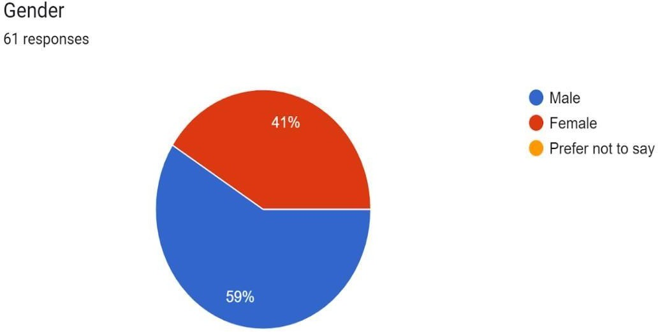

#### Figure 4.1

From the above data it can be seen that maximum number of respondents are male i.e., 59% and the remaining are female i.e., 41%. This means that the study convers maximum male respondents when compared to female.

#### Age Group

**Table 4.2**

|  |  |  |  |
| --- | --- | --- | --- |
|  | 18-25 | 26-30 | Above 30 |
| No of respondents | 53 | 2 | 6 |

### SOURCE: PRIMARY DATA

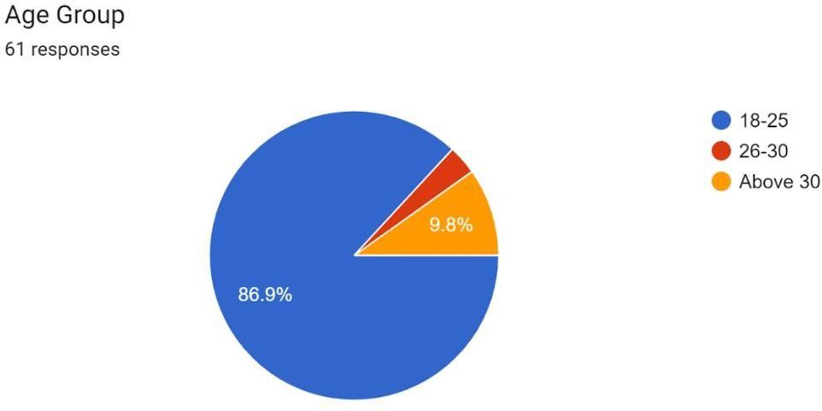

#### Figure 4.2

From the above data it can be seen that maximum number of respondents belong to the age group of 18-25 i.e., 86.9%, around 3.3% of the respondents belong to the age group of 26-30. And the age group of above 30 i.e., 9.8%. It can be understood that the study covers the maximum number of respondents from the age group 18-25.

#### Occupation

**Table 4.3**

|  |  |  |  |
| --- | --- | --- | --- |
|  | Student | employee | Home maker |
| No of respondents | 51 | 8 | 2 |

### SOURCE: PRIMARY DATA

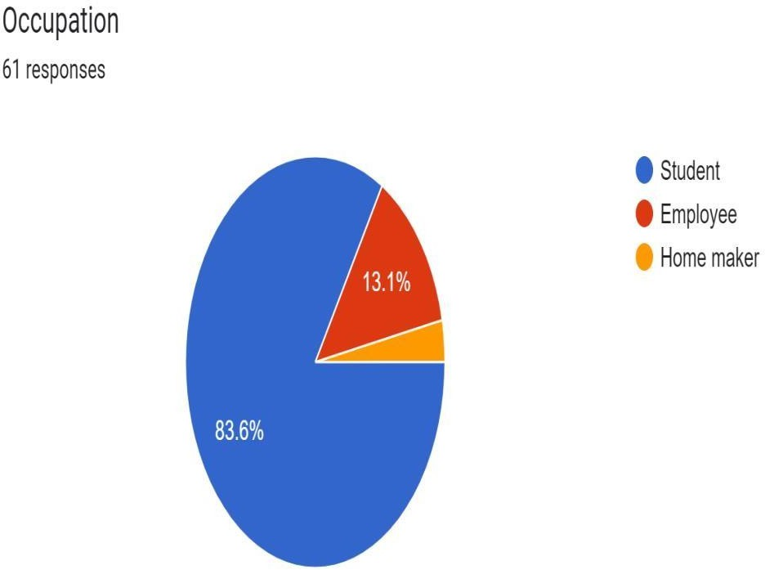

#### Figure 4.3

From the above data it can be seen that maximum number of respondents i.e., 83.6% of them are students. Around 13.1% of the respondents are employees whereas 3.3% of them are home makers. It can be understood that maximum number of respondents are students.

#### State

**Table 4.4**

|  |  |  |  |  |  |
| --- | --- | --- | --- | --- | --- |
|  | Telangana | Andharapradesh | Karnataka | Maharashtra | Bihar |
| No of  respondents | 31 | 26 | 1 | 1 | 1 |

### SOURCE: PRIMARY DATA

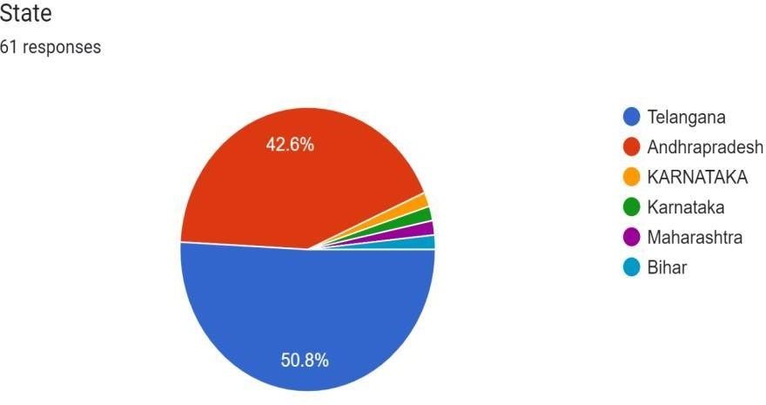

#### Figure 4.4

From the above data it can be seen that maximum number of respondents i.e., 50.8% of them belong to Telangana state. Around 42.6% of the respondents beiong to Andhrapradesh whereas 6.6% of them belongs to Karnataka, Maharashtra, Bihar. It can be understood that maximum number of respondents belong to Teangana state.

#### Are you aware of the term viral marketing?

**Table 4.5**

|  |  |  |
| --- | --- | --- |
|  | Yes | No |
| No of respondents | 48 | 13 |

### SOURCE: PRIMARY DATA

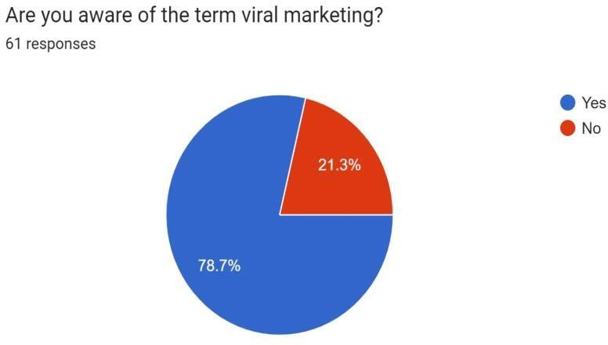

#### Figure 4.5

From the above data it can be seen that maximum number of respondents are aware of the term viral marketing i.e., around 78.8% of the respondents and around 21.3% of the consumers are not aware of the term viral marketing.

This shows that there are a lot of respondents who are aware about viral marketing.

#### Is your purchasing decision influenced by advice from others?

**Table 4.6**

|  |  |  |
| --- | --- | --- |
|  | Yes | No |
| No of respondents | 42 | 19 |

### SOURCE: PRIMARY DATA

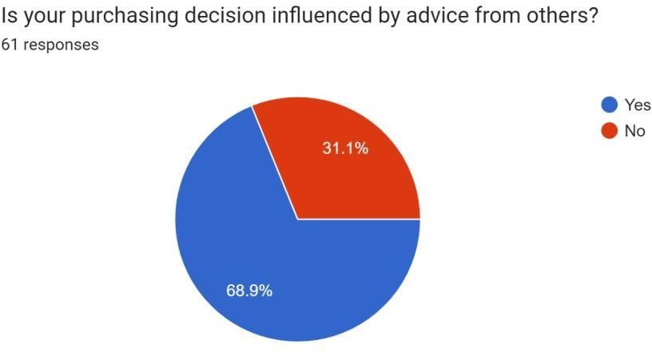

#### Figure 4.6

From the above data it can be seen that maximum number of respondents are sometimes influenced by advice from others i.e., 68.9% of the respondents. Around 31.1% of respondents are never influenced by advice from others.

It can be understood that there are a lot of respondents who are sometimes influenced by advice from others.

#### How often do you come across advertisements when surfing social networking sites or sending emails?

**Table 4.7**

|  |  |  |  |
| --- | --- | --- | --- |
|  | Everyday | Rarely | Not at all |
| No of respondents | 31 | 28 | 2 |

### SOURCE: PRIMARY DATA

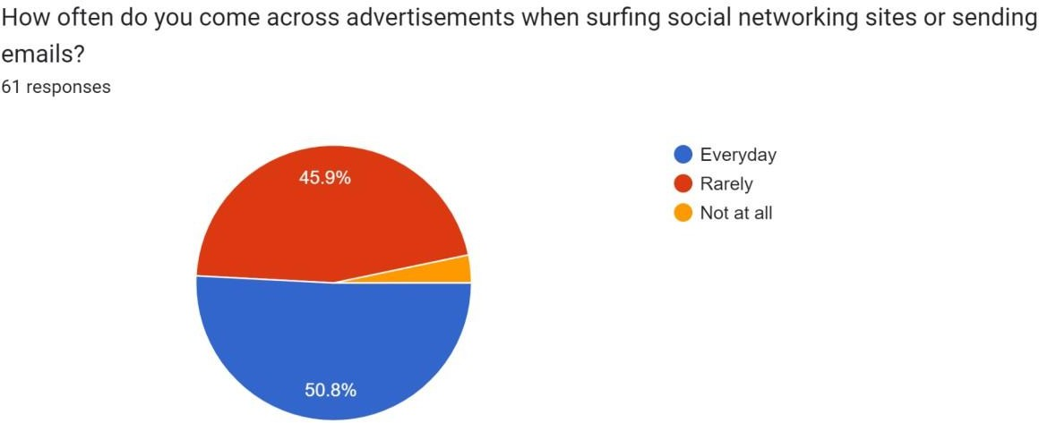

#### Figure 4.7

From the above data it can be seen that many respondents come across advertisements everyday i.e., around 50.8% of the respondents. Around 45.9% of the respondents come across advertisements rarely. Around 3.3% of the respondents do not come across advertisements at all.

It can be understood that there are a lot of respondents who come across advertisements every day.

#### Do you go through the advertisements?

**Table 4.8**

|  |  |  |
| --- | --- | --- |
|  | Yes | No |
| No of respondents | 45 | 16 |

### SOURCE: PRIMARY DATA

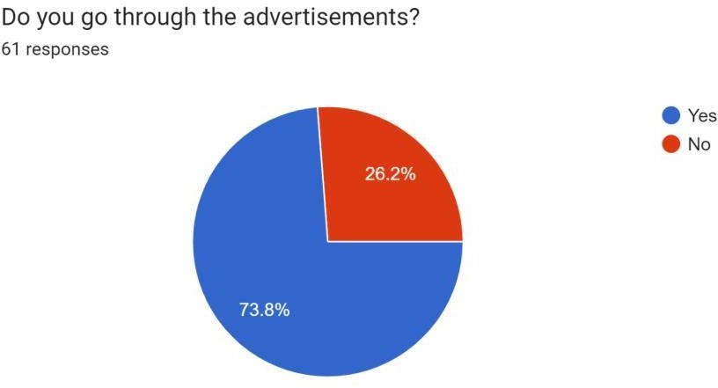

#### Figure 4.8

From the above data it is observed that maximum number of the respondents i.e., around 73.8% of the respondents go through advertisements. Around 26.2% of the respondents do not go through the advertisements.

It can be understood that maximum number of respondents go through the advertisements.

1. **If Yes, Reason**

### [THE REASON WHY RESPONDENTS GO THROUGH THE ADVERTISEMENTS]

**Table 4.9**

|  |  |  |
| --- | --- | --- |
|  | Informative | Attractive |
| No of respondents | 35 | 19 |

### SOURCE: PRIMARY DATA

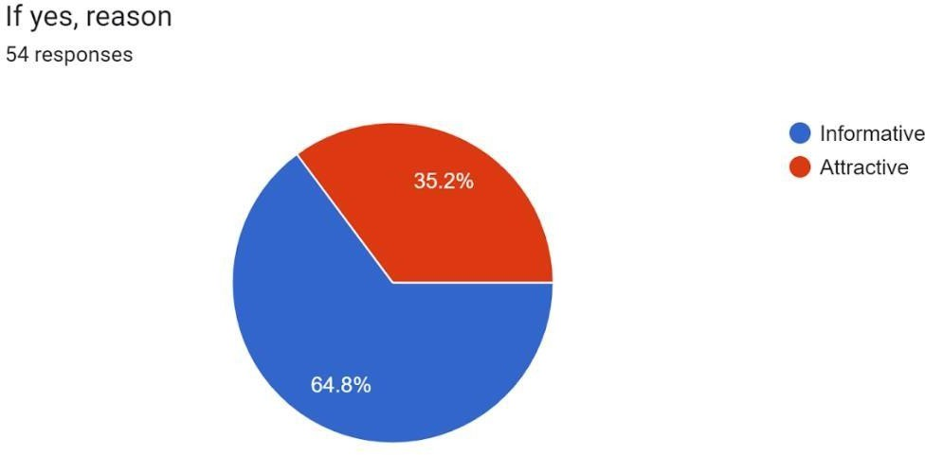

#### Figure 4.9

The main reason why respondents go through advertisements are:

64.8% of the respondents go through the advertisements because they feel they are informative and 35.2% of the respondents go through the advertisements because they fell they are attractive.

It can be understood that the main reason why respondents go through advertisements is because advertisements is because they find them informative.

1. **If No, Reason**

### [THE REASON WHY RESPONDENTS DON’T GO THROUGH THE ADVERTISEMENTS]

**Table 4.10**

|  |  |  |  |
| --- | --- | --- | --- |
|  | **Waste of time** | **Not informative** | **Not of any use** |
| **No of respondents** | **17** | **13** | **10** |

### SOURCE: PRIMARY DATA

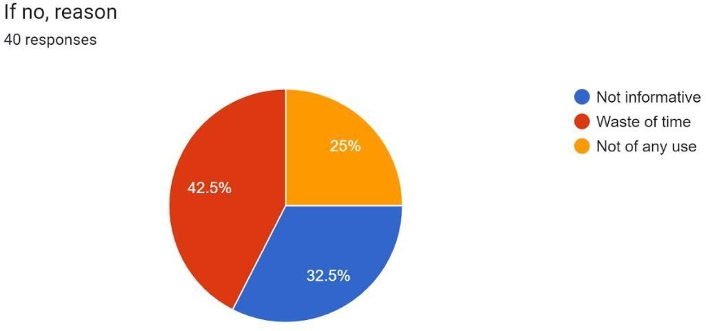

#### Figure 4.10

The main reason why people do not go through advertisements are:

42.5% of the respondents believe that the advertisements are a waste of time. 32.5% of the respondents believe that the advertisements are not informative and 25% of the respondents believe that advertisements are not of any use.

It can be understood that maximum respondents consider advertisements as waste of time.

#### What you seek from advertisements?

**Table 4.11**

|  |  |  |  |  |
| --- | --- | --- | --- | --- |
|  | Information | Sound | Music | Visuals |
| No of  respondents | 46 | 4 | 3 | 3 |

### SOURCE: PRIMARY DATA

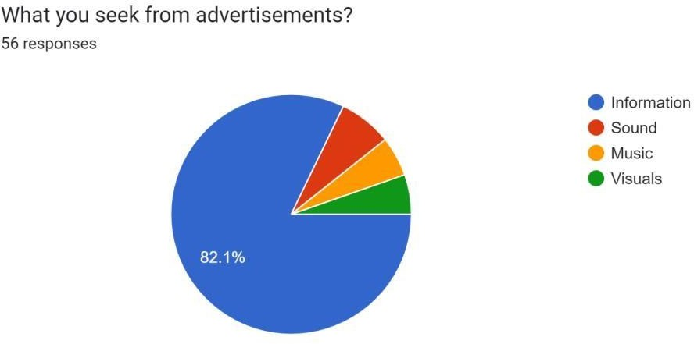

#### Figure 4.11

From the above data it can observed that maximum number of the respondents seek information from advertisements i.e., around 82.1% of the respondents and the remaining respondents seek sound around 7.9%, music around 5% and visuals around 5%.

It can be understood that maximum number respondents seek information from advertisements.

#### Do you respond to the advertisement?

**Table 4.12**

|  |  |  |  |
| --- | --- | --- | --- |
|  | Everytime | Rarely | Once in a while |
| No of respondents | 11 | 32 | 18 |

### SOURCE: PRIMARY DATA

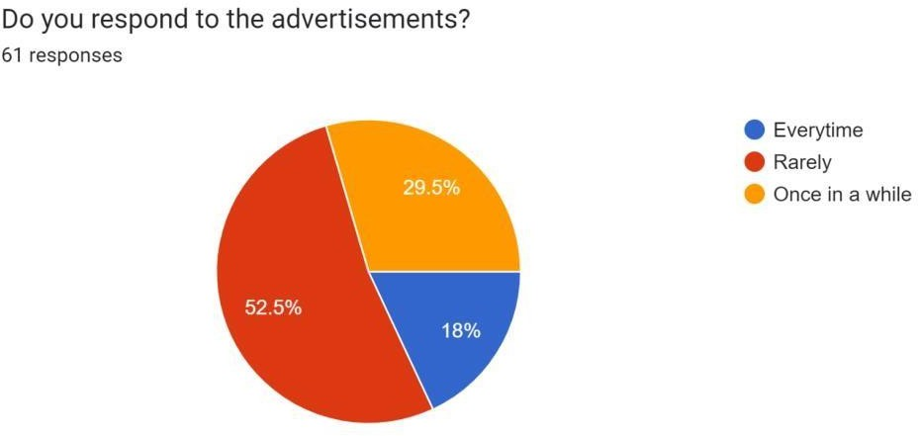

#### Figure 4.12

From the above data it is observed that maximum number of the respondents do respond to the advertisements rarely i.e., 52.5% of the respondents. Around 29.5% of the respondents respond to the advertisements once in a while and 18% of the respondents respond every time to the advertisements.

It can be understood that maximum number of respondents do respondents do respond rarely.

#### How often do you pass the information to your friends?

**Table 4.13**

|  |  |  |  |
| --- | --- | --- | --- |
|  | **Rarely** | **Never** | **Quite often** |
| **No of respondents** | **35** | **10** | **16** |

### SOURCE: PRIMARY DATA

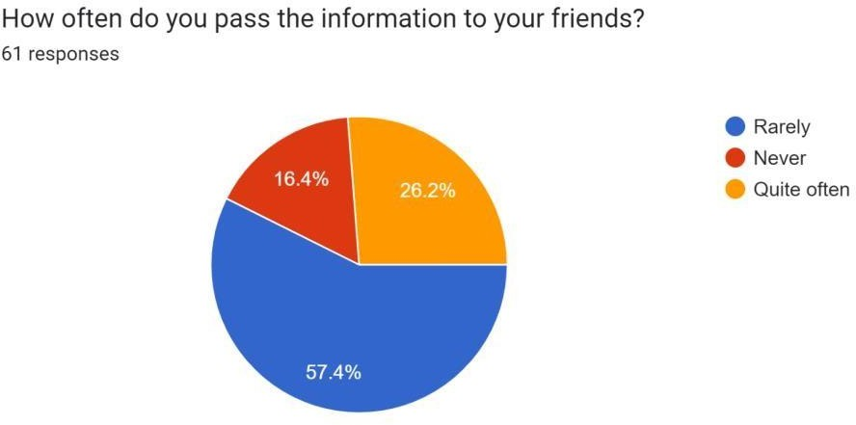

#### Figure 4.13

From the above data it can be seen that around 57.4% of the consumers rarely pass the information to their friends and around 26.2% of the consumers pass the information to their friends and around 16.4% of the consumers never pass the information to their friends.

It can be understood that the respondents sometimes/rarely pass the information to their friends.

#### What are the factors that influence you to receive or forward messages?

**Table 4.14**

|  |  |  |  |
| --- | --- | --- | --- |
|  | **Informative** | **Helpful** | **Innovative** |
| **No of respondents** | **23** | **22** | **16** |

### SOURCE: PRIMARY DATA

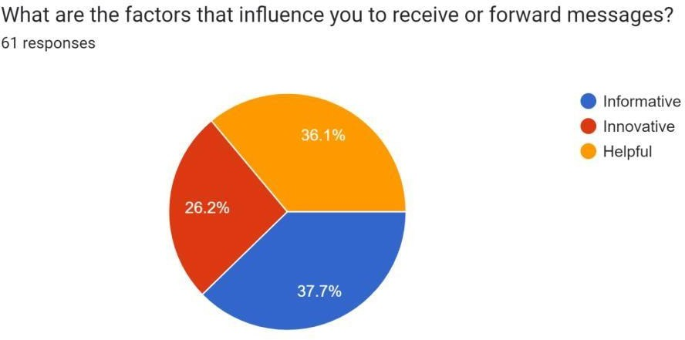

#### Figure 4.14

The main factor that influence respondents to receive or forward messages are:

36.1% of the respondents believe the messages are helpful. Around 26.2% of the respondents believe the messages are innovative and around 37.7% of the respondents believe the messages are informative.

It can be understood that maximum number of the respondents are influenced by advertisements because they feel advertisements are informative.

#### Do you agree that viral marketing is an effective advertising campaign?

**Table 4.15**

|  |  |  |  |  |  |
| --- | --- | --- | --- | --- | --- |
|  | Strongly agree | Agree | Neutral | Disagree | Strongly disagree |
| No of  respondents | 9 | 27 | 23 | 2 | 0 |

### SOURCE: PRIMARY DATA

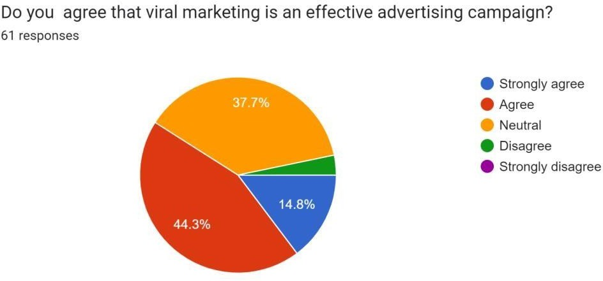

#### Figure 4.15

From the data it can be seen that maximum number of respondents agrees that viral marketing is an effective advertising campaign i.e., 44.3% of the respondents. Around 37.7% of the respondents have a neutral opinion regarding viral marketing being an effective advertising campaign and around 14.8% of the respondents strongly agree that viral marketing is effective. Around 3.2% of the respondents disagree that viral marketing is not effective. It can be understood that maximum respondents strongly believe that viral marketing is an effective marketing technique.

#### Does viral marketing helps create brand awareness?

**Table 4.16**

|  |  |  |
| --- | --- | --- |
|  | **Yes** | **No** |
| **No of respondents** | **55** | **06** |

### SOURCE: PRIMARY DATA

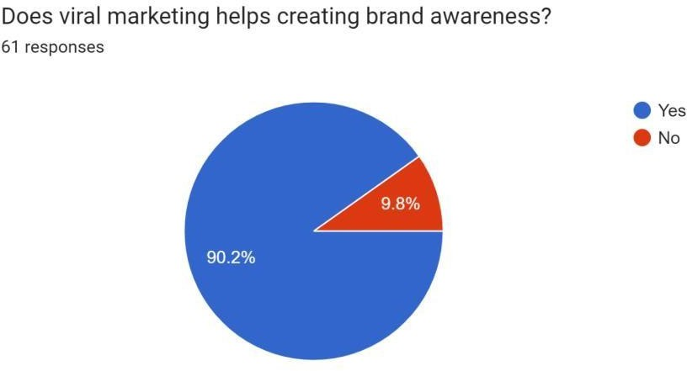

#### Figure 4.16

From the above data it can be seen that maximum respondents agree that viral marketing helps create brand awareness i.e., around 90.2% of the respondents and 9.8% of the respondents do not agree that viral marketing helps for brand awareness.

It can be under stood that maximum respondents agree that viral marketing is a helpful strategy to create brand awareness.

#### Do you think viral marketing is a better technique compared to others?

**Table 4.17**

|  |  |  |
| --- | --- | --- |
|  | **Yes** | **No** |
| **No of respondents** | **54** | **7** |

### SOURCE: PRIMARY DATA

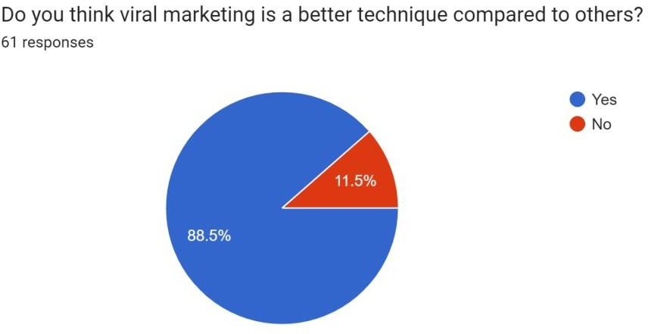

#### Figure 4.17

From the above data it can be said that around 88.5% of the respondents believe that viral marketing is a better technique compared to any other technique whereas 11.5% of the respondents believe that viral marketing is not a better technique compared to the other.

It can be understood that respondents believe and agree that viral marketing is a better technique.

#### If yes, what makes it better?

**Table 4.18**

|  |  |  |
| --- | --- | --- |
|  | **Convenience** | **Attractive** |
| **No of respondents** | **35** | **26** |

### SOURCE: PRIMARY DATA

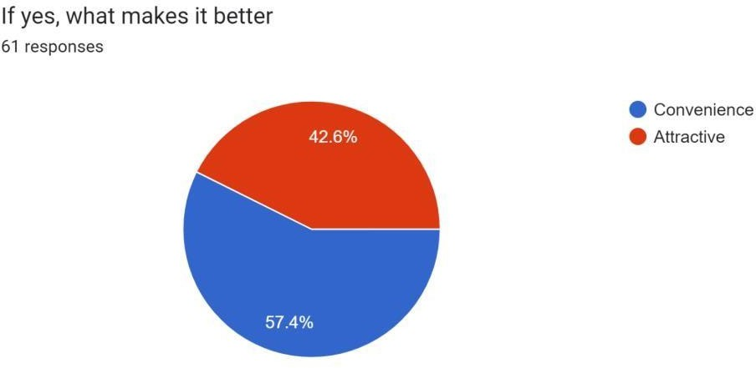

#### Figure 4.18

From the above data it can be said that respondents find viral marketing a better technique for the reasons:

Around 57.4% of the respondents find viral marketing as convenience and the other 42.6% of the respondents find viral marketing as attractive.

It can be understood that respondents find viral marketing an effective technique because respondents find it convenience.

1. **What according to you will be the scope of viral marketing in near future? Table 4.19**

|  |  |  |  |
| --- | --- | --- | --- |
|  | **Broad** | **Narrow** | **No scope** |
| **No of respondents** | **42** | **15** | **4** |

### SOURCE: PRIMARY DATA

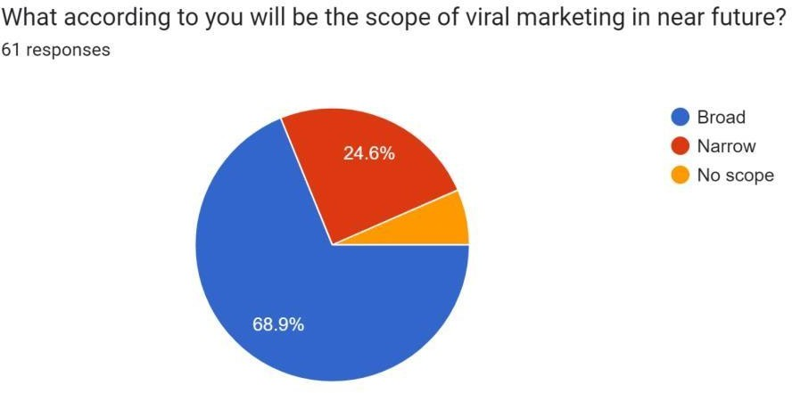

#### Figure 4.19

From above data it can be seen that the number of the respondents believe that the scope of viral marketing would be Broad in the future i.e., 68.9%. Around 24.6% of the respondents believe that scope would be narrow and 8.5% of the respondents believe the scope of viral marketing in near future would have no scope. It can be understood that respondents agree that scope of viral marketing is huge in future.

# CHAPTER 5 FINDINGS, SUGGESTIONS AND CONCLUSIONS

### FINDINGS

* + 1. It can be understood from the data that respondents consider viral marketing an effective technique for marketing.
    2. Respondents believe that viral marketing helps to create brand awareness.
    3. Respondents find advertisements to be a not of any use and less information.
    4. Respondents usually respond to advertisements because they find them informative, innovation and helpful.
    5. Maximum number of respondents feel viral marketing as a better technique because of its convenience.
    6. maximum number of respondents are sometimes influenced by advice from others 68.9% of the respondents. Around 31.1% of respondents are never influenced by advice from others.
    7. many respondents come across advertisements everyday around 50.8% of the respondents. Around 45.9% of the respondents come across advertisements rarely and around 3.8% respondents are not going through advertisements.
    8. We observed that maximum number of the respondents do respond to the advertisements rarely 52.5% of the respondents. Around 29.5% of the respondents respond to the advertisements once in a while and 18% of the respondents respond every time to the advertisements.
    9. We came to know 57.4% of the consumers rarely pass the information to their friends and around 26.2% of the consumers pass the information to their friends and around 16.4% of the consumers never pass the information to their friends.
    10. maximum respondents agree that viral marketing helps create brand awareness around 90.2% of the respondents and 9.8% of the respondents do not agree that viral marketing helps for brand awareness.
    11. Since most of the feedback we received is from students we can say that students activity take part in reviews and feedback systems.
    12. Around 73.8% of the respondents go through advertisements. Around 26.2% of the respondents do not go through the advertisements.
    13. It can be understood that maximum number of respondents go through the advertisements. Advertisements are attracting.
    14. 64.8% of the respondents go through the advertisements because they feel they are informative and 35.2% of the respondents go through the advertisements because they fell they are attractive. It can be understood that the main reason why respondents go through advertisements is because advertisements is because they find them informative.
    15. The main reason why people do not go through advertisements are: 42.5% of the respondents believe that the advertisements are a waste of time. 32.5% of the respondents believe that the advertisements are not informative and 25% of the respondents believe that advertisements are not of any use. It can be understood that maximum respondents consider advertisements as waste of time.
    16. maximum number of the respondents seek information from advertisements i.e., around 82.1% of the respondents and the remaining respondents seek sound around 7.9%, music around 5% and visuals around 5%.
    17. maximum number of the respondents do respond to the advertisements rarely i.e., 52.5% of the respondents. Around 29.5% of the respondents respond to the advertisements once in a while and 18% of the respondents respond every time to the advertisements. It can be understood that maximum number of respondents do respondents do respond rarely.
    18. It can be seen that around 57.4% of the consumers rarely pass the information to their friends and around 26.2% of the consumers pass the information to their friends and around 16.4% of the consumers never pass the information to their friends.

It can be understood that the respondents sometimes/rarely pass the information to their friends.

* + 1. 36.1% of the respondents believe the messages are helpful. Around 26.2% of the respondents believe the messages are innovative and around 37.7% of the respondents believe the messages are informative.

It can be understood that maximum number of the respondents are influenced by advertisements because they feel advertisements are informative.

* + 1. Around 57.4% of the respondents find viral marketing as convenience and the other 42.6% of the respondents find viral marketing as attractive.

It can be understood that respondents find viral marketing an effective technique because respondents find it convenience.

### SUGGESTIONS

* + 1. It would preferable for companies to go for viral marketing because it is considered to be a better technique when compared to the other marketing techniques due to its convenience
    2. For companies wanting to create and improve the brand images of their products, they must go with viral marketing.
    3. Companies wanting to cover the group of consumers who do not respond to advertisements must try to highlight their offers and qualities using viral marketing. 4. Companies must try and make their advertisements more informative, interesting and entertaining for consumers to go through them because consumers find the advertisements a waste of time.

1. Companies must keep their advertisements both shareable and share worthy.
2. Staying in the rader of people is not an easy task and hence viral marketing is a great strategy for doing that as well as building of brand image for companies
3. The companies must try to entertain, inform and strategically continue to evolve across different platforms.

**CONCLUSIONS**

1. There are a lot of respondents who are aware of the term viral marketing.
2. The purchasing behaviors of consumers is mostly influenced by viral marketing.
3. Respondents believe that viral marketing is an effective marketing technique when compared to any other marketing technique.
4. Respondents usually forward advertisements to their friends when they find them informative.
5. Many respondents believe that viral marketing helps create brand awareness.

**Bibilography**

|  |  |  |
| --- | --- | --- |
| **Bibliography** |  |  |
| - | [**https://www.investopedia.com/terms/m/marketing.asp**](https://www.investopedia.com/terms/m/marketing.asp) |  |
| - | [**https://www.cyberclick.net/numericalblogen/what-is-viralmarketing-**](https://www.cyberclick.net/numericalblogen/what-is-viral-marketing-advertising-and-examples) |  |
|  | [**advertising-and-examples**](https://www.cyberclick.net/numericalblogen/what-is-viral-marketing-advertising-and-examples) |  |
| - | [**https://startuptalky.com/top-viral-campaigns-analysis/**](https://startuptalky.com/top-viral-campaigns-analysis/) |  |
| - | [**https://zoom.us/**](https://zoom.us/) |  |
| - | [**https://www.businessinsider.in/tech/apple-invested-a-newtype-of-vir**](https://www.businessinsider.in/tech/apple-invested-a-new-type-of-viral-advertising-that-can-track-users-in-social-media/articleshow/47721508.cms) | [**al-**](https://www.businessinsider.in/tech/apple-invested-a-new-type-of-viral-advertising-that-can-track-users-in-social-media/articleshow/47721508.cms) |
|  |  |
|  | [**advertising-that-can-track-users-in-**](https://www.businessinsider.in/tech/apple-invested-a-new-type-of-viral-advertising-that-can-track-users-in-social-media/articleshow/47721508.cms) |  |
|  | [**socialmedia/articleshow/47721508.cms**](https://www.businessinsider.in/tech/apple-invested-a-new-type-of-viral-advertising-that-can-track-users-in-social-media/articleshow/47721508.cms) |  |
| - | [**http://www.linkedin.com/pulse/how-doves-real-beautycampaign-wen**](http://www.linkedin.com/pulse/how-doves-real-beauty-campaign-went-massively-viral-jason-brownlee) | [**t-**](http://www.linkedin.com/pulse/how-doves-real-beauty-campaign-went-massively-viral-jason-brownlee) |
|  |  |
|  | [**massively-viral-jason-brownlee**](http://www.linkedin.com/pulse/how-doves-real-beauty-campaign-went-massively-viral-jason-brownlee) |  |
| - | [**https://iheartdogs.com/**](https://iheartdogs.com/) |  |
| - | [**https://business.twitter.com/en/advertising/launch.html**](https://business.twitter.com/en/advertising/launch.html) |  |
| - | [**https://www.marketingweek.com/uber-turns-to-traditionaladvertising**](https://www.marketingweek.com/uber-turns-to-traditional-advertising-for-its-first-major-outdoor-ad-campaign/) | [**-**](https://www.marketingweek.com/uber-turns-to-traditional-advertising-for-its-first-major-outdoor-ad-campaign/) |
| [**for-its-first-major-outdoor-ad-campaign/**](https://www.marketingweek.com/uber-turns-to-traditional-advertising-for-its-first-major-outdoor-ad-campaign/)  [**https://techcrunch.com/2021/04/19/facebook-is-expandingspotify-**](https://techcrunch.com/2021/04/19/facebook-is-expanding-spotify-partnership-with-new-boombox-project/)[**partnership-with-new-boombox-project/**](https://techcrunch.com/2021/04/19/facebook-is-expanding-spotify-partnership-with-new-boombox-project/)  [**https://help.dropbox.com/accounts-billing/spacestorage/earn-space-**](https://help.dropbox.com/accounts-billing/space-storage/earn-space-referring-friends)[**referring-friends**](https://help.dropbox.com/accounts-billing/space-storage/earn-space-referring-friends)  [**https://deepstash.com/idea/219874/i-want-mint-badge**](https://deepstash.com/idea/219874/i-want-mint-badge)  [**https://www.als.org/stories-news/ice-bucket-challengedramatically-**](https://www.als.org/stories-news/ice-bucket-challenge-dramatically-accelerated-fight-against-als)[**accelerated-fight-against-als**](https://www.als.org/stories-news/ice-bucket-challenge-dramatically-accelerated-fight-against-als)  62 |
| - |  |
| - |  |
| - |  |
| - |  |

**Annexure:**

1. Name
2. Email ID
3. Gender

*Mark only one.*

* + Male o Female o Prefer not to say

1. Age group

*Mark only one.*

* + 18-25 o 26-

30 o Above 30

1. Occupation

*Mark only one.*

* + Student o Employee o Home maker

1. State

*Mark only one.*

* + Telangana o Andhrapradesh o Other:

1. Are you aware of the term viral marketing?

*Mark only one.*

* + Yes o No

1. Is your purchasing decision influenced by advice from others?

*Mark only one.*

* + Yes o No

1. How often do you come across advertisements when surfing social networking sites on sending emails?

*Mark only one.*

* + Everyday o Rarely o Not at all

1. Do you go through the advertisements?

*Mark only one.*

* + Yes o No

1. If yes, reason

*Mark only one*

* + Informative
  + Attractive

1. If no, reason

*Mark only one.*

* + Not informative o Waste of time
  + Not of any use

1. What you seek from advertisements?

*Mark only one.*

* + Information
  + Sound o

Music o Visuals

1. Do you respond to the advertisements?

*Mark only one.*

* + Everytime
  + Rarely o

Once in a while

1. How often do you pass the information to your friends?

*Mark only one.*

* + Rarely o Never o Quite often

1. What are the factors that influence you to receive or forward messages?

Mark only one.

* + Informative
  + Innovative o

Helpful

1. Do you agree that viral marketing is an effective advertising campaign?

*Mark only one.*

* + Strongly

agree o Agree o Neutral o Disagree o

Strongly disagree

1. Does viral marketing helps creating brand awareness?

*Mark only one.*

* + Yes o No

1. Do you think viral marketing is a better technique compared to others?

*Mark only one.*

* + Yes o No

1. If yes, what makes it better

*Mark only one*

* + Convenienc e o Attractive

1. What according to you will be the scope of viral marketing in near future?

*Mark only one.*

* + Broad o Narrow o No scope